6A^{th} Grade: Unit 11, Lesson 8

- What step should be performed first to evaluate the expression $8-6+2^{5}∙4$?

Evaluate the exponent.

- What operation should be performed first to evaluate, $5.8÷2.9+{(-4)}^{0}$?

$${(-4)}^{0}$$

- Which step should you complete first in the expression $(4-6+8+3-2+6)$?

$$4-6$$

- What is the first step in evaluating ${\left|16+(-3)×7\right|}^{3}$.

$${\left|16+(-21)\right|}^{3}$$

- Aubrey and Trey evaluated ${(3+5)}^{2}÷2$ using the order of operations. Who correctly evaluated the expression?
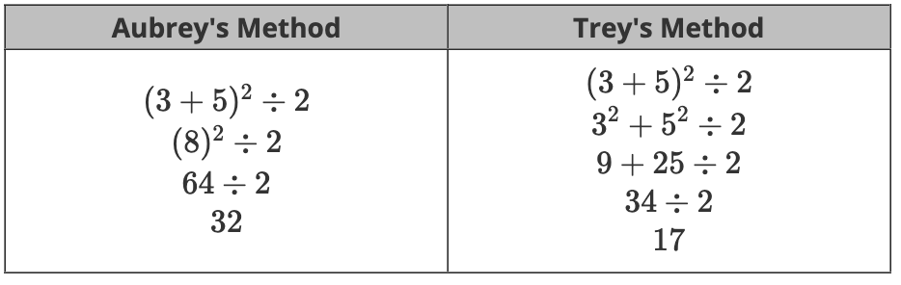

Aubrey

- Is the following a correct equivalence?
$$\left[12÷3+{(4+5)}^{2}\right]=\left[12÷3+9^{2}\right]$$

Yes

